

Information and Communication Technologies

**T I C**

**AUTHORS :**

BELMADI AHMED

HOUCHINE ABD EL SAMED

YASSER

**Table of Contents**

1. **Introduction to Information and Communication Technologies (ICT)**
   * Definition of ICT
   * Key Components of ICT
   * Importance of ICT
2. **Google Services**
   * Search and Discovery
     + Google Search
     + Google News
     + Google Trends
   * Communication and Collaboration
     + Gmail
     + Google Meet
     + Google Chat
     + Google Drive
   * Content Creation and Productivity
     + Google Docs, Sheets, and Slides
     + Google Forms
     + Google Keep
   * Entertainment and Media
     + YouTube
     + Google Play
     + YouTube Music
   * Navigation and Travel
     + Google Maps
     + Google Earth
     + Google Flights
   * Artificial Intelligence and Machine Learning
     + Google Assistant
     + Google Translate
     + Google Lens
   * Business Solutions
     + Google Ads
     + Google Analytics
     + Google Workspace
3. **Microsoft Tools**
   * Microsoft Word
   * Microsoft Excel
   * Microsoft PowerPoint
   * Microsoft Outlook
   * Microsoft Teams
   * OneDrive
   * Windows OS
   * Microsoft Edge
   * Power BI
   * Xbox
4. **Git and GitHub**
   * Introduction to Git
   * Key Features of GitHub
   * Role of Git and GitHub in Modern Software Development
   * GitHub’s Impact on Collaboration and Innovation

**Introduction :**

Information and Communication Technologies (TIC) encompass the tools, systems, and technologies used to manage, transmit, and process information. TIC integrates diverse communication technologies such as telecommunications, broadcasting, computing, and data management to facilitate the seamless exchange of information across the globe

TIC is a cornerstone of the modern digital era, driving innovation, productivity, and connectivity in various sectors, including education, healthcare, business, and governance. By bridging geographical gaps, enhancing access to knowledge, and enabling real-time communication, TIC has transformed how individuals, organizations, and governments operate.

**Key Components of TIC:**

**Hardware:** Physical devices like computers, servers, smartphones, and networking equipment.

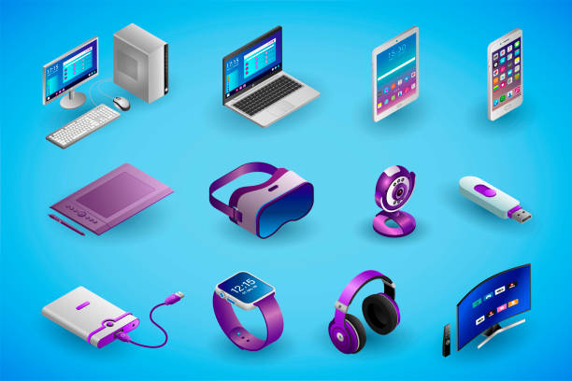

**Software:** Applications, operating systems, and platforms used to manage and utilize hardware.

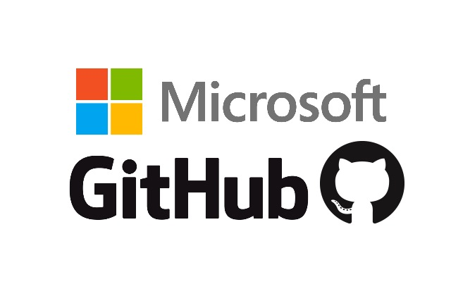

**Networks:** Infrastructure enabling connectivity, including the internet, intranets, and telecommunications networks.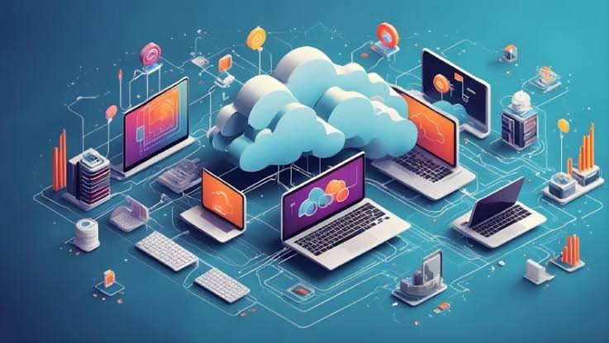

**Data:** The raw information collected, processed, and shared through tic systems.

**Importance of TIC:**

**Connectivity:** Facilitates communication regardless of distance.

**Efficiency:** Enhances operational workflows in industries.

**Innovation:** Drives the development of new tools and services.

**Inclusion:** Promotes access to education, health services, and economic opportunities.

TIC has evolved into an essential aspect of daily life, fostering globalization and contributing to the sustainable development of societies. Its potential to address pressing challenges, such as climate change, education inequities, and healthcare disparities, underscores its significance in shaping the future.

**Google Services:**

Google, founded in 1998 by Larry Page and Sergey Brin, has grown from a simple search engine into a global technology leader offering a diverse range of services and products. These services cater to individuals, businesses, and developers, empowering them to connect, collaborate, and innovate. Here's an overview of Google's key services categorized by their primary functions.

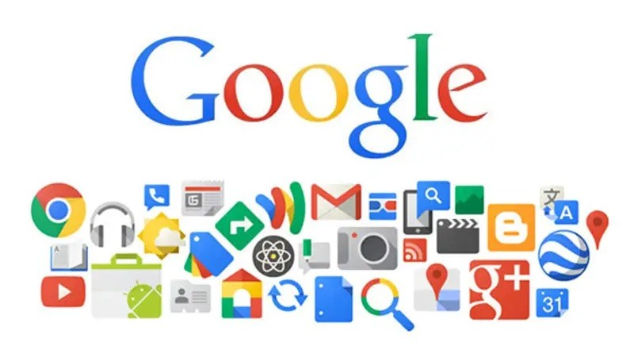

**1. Search and Discovery**

**Google Search**:

* Core service that helps users find information from the web.
* Features include autocomplete, personalized results, and instant answers.

**Google News**:

* A platform for aggregated news from various publishers.
* Provides curated updates on global and local events.

**Google Trends**:

* Offers insights into popular searches and trends over time.

**2. Communication and Collaboration**

**Gmail**:

* One of the most widely used email services globally.
* Features include spam filtering, smart replies, and extensive storage.

**Google Meet**:

* A video conferencing platform for virtual meetings and webinars.
* Supports features like screen sharing and live captions.

**Google Chat**:

* A messaging app integrated with Gmail for team communication.

**Google Drive**:

* A cloud storage solution for saving and sharing files securely.
* Includes seamless integration with Google Docs, Sheets, and Slides.

**3. Content Creation and Productivity**

**Google Docs, Sheets, and Slides**:

* Online tools for word processing, spreadsheets, and presentations.
* Allow real-time collaboration and automatic saving in the cloud.

**Google Forms**:

* Tool for creating surveys, quizzes, and feedback forms.

**Google Keep**:

* A note-taking application for organizing ideas and tasks.

**4. Entertainment and Media**

**YouTube**:

* The world’s largest video-sharing platform.
* Offers videos, live streaming, and original content from creators.

**Google Play**:

* A digital distribution platform for apps, games, music, movies, and books.

**YouTube Music**:

* A music streaming service with personalized playlists and offline listening.

**5. Navigation and Travel**

**Google Maps**:

* A mapping and navigation service with real-time traffic updates.
* Includes features like street view, satellite imagery, and local business listings.

**Google Earth**:

* A virtual globe for exploring the world’s geography in detail.

**Google Flights**:

* A service to search, compare, and book airline tickets.

**6. Artificial Intelligence and Machine Learning**

**Google Assistant**:

* A virtual assistant for managing tasks, setting reminders, and answering queries.

**Google Translate**:

* A language translation tool supporting text, voice, and image translations.

**Google Lens**:

* A visual search tool that identifies objects, translates text, and finds similar items.

**7. Business Solutions**

**Google Ads**:

* An advertising platform for creating campaigns across search, display, and video.

**Google Analytics**:

* A tool for analyzing website traffic and user behavior.

**Google Workspace (formerly G Suite)**:

* A suite of productivity tools including Gmail, Calendar, Drive, and Docs designed for businesses.

**Microsoft Tools:**

Microsoft Corporation, founded in 1975 by **Bill Gates** and **Paul Allen**, is one of the most influential technology companies in the world. Its journey from a small software startup to a global leader in computing, software, and technology innovation is a story of vision, perseverance, and groundbreaking innovation.

Here are the most widely used Microsoft tools, known for their impact on productivity, collaboration, and personal use:

**1. Microsoft Word**

* Popular word processor for creating documents, resumes, and reports.
* Essential for personal, educational, and professional use.

**2. Microsoft Excel**

* A go-to tool for data analysis, budgeting, and creating spreadsheets.
* Frequently used in businesses for financial modeling and reporting.

**3. Microsoft PowerPoint**

* Widely used for creating engaging presentations for meetings, lectures, and training.

**4. Microsoft Outlook**

* A versatile tool for managing email, calendar, and contacts.
* Common in workplace communication and scheduling.

**5. Microsoft Teams**

* A leading platform for chat, video conferencing, and collaboration.
* Integrated into many organizations for remote work and team projects.

**6. OneDrive**

* Cloud storage service for saving, syncing, and sharing files.
* Ensures accessibility across devices.

**7. Windows OS**

* The operating system powering billions of personal computers worldwide.
* Central to daily computing activities.

**8. Microsoft Edge**

* A web browser known for speed, security, and integration with other Microsoft services.

**9. Power BI**

* A tool for creating interactive dashboards and visualizations.
* Essential in business intelligence and data analytics.

**10. Xbox**

* A leading gaming platform with consoles and online gaming services.

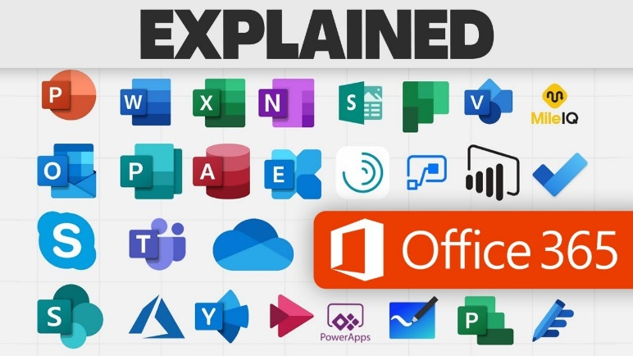

**Git and github :**

GitHub operates on Git, an open-source version control system created by Linus Torvalds in 2005 for managing the Linux kernel's development. Git allows developers to track file changes, maintain a history, and experiment with new features via branching. This branching model ensures testing of changes before merging into the main codebase.

GitHub enhances Git with features such as **Pull Requests**, **Issue Tracking**, and **Workflow Automation** through **GitHub Actions**. Developers can push updates to remote repositories, collaborate with team members, and streamline project management. GitHub also supports **GitHub Pages** for easy website deployment and integrates with tools like Jenkins, Docker, and Slack.

Git and GitHub revolutionized software development by enabling independent work with Git's decentralized model, reducing conflicts, and simplifying debugging. GitHub centralizes collaboration, fosters global open-source contributions, and accelerates innovation.